How to self-isolate for COVID-19 |  |  |  | 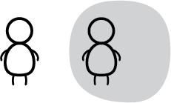
You can save lives if you stay home. If you are infected with COVID-19, you can infect many people. This includes older relatives and neighbours. |  |  |  | Live in an  apartment or condo?
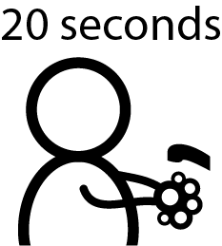 | 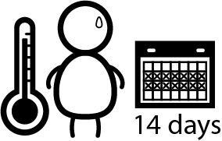 | 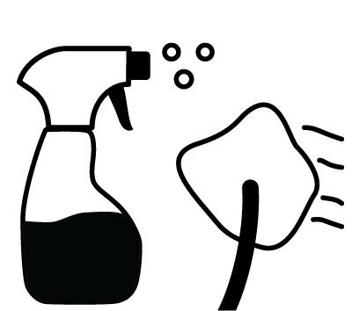 |  | 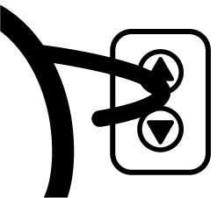 | 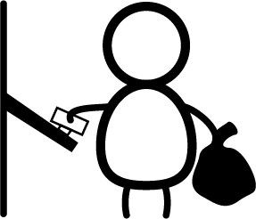
Wash hands often. Do not touch your face. | Watch your symptoms for 14 days | Clean and disinfect your home often |  | Use elbows  or knuckles  for elevator buttons | Use paper towel to touch the garbage chute
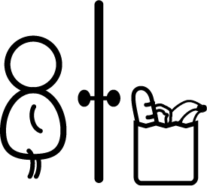 |  |  |  |  | 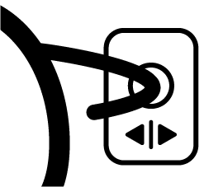
Get food and groceries delivered | Work from home or stop work | Stay in contact by phone and online |  | Take the stairs when possible | Push automatic door openers with elbows or knuckles

What to do if you live with other people and are sick
 | 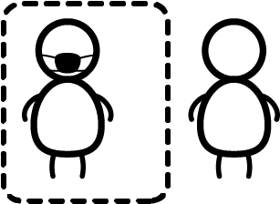
Use different cups and dishes. Clean and disinfect them often. | Stay in different areas. Use a different bathroom if possible | Wash your hands before and after petting pets, or try  not to pet them | Keep 2 meters apart or wear a mask

