[Hospital/clinic Name Here]

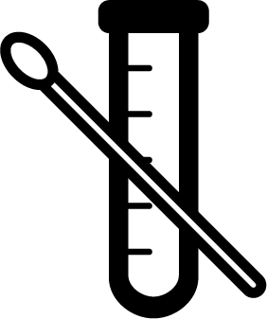
Why am I not being tested for COVID-19?

You may want to be tested when you are feeling unwell or nervous.
- Most people with COVID-19 are best cared for at home.
- We currently test only when it changes your treatment.

You may only be tested if:
 | 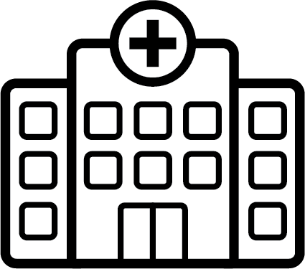 |  | 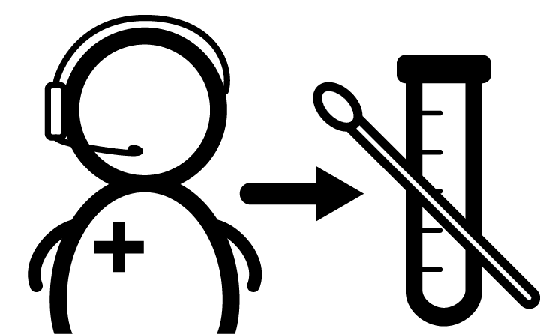
You work or live in  a high risk setting  (e.g., hospital, homeless  shelter, prison) | You are admitted to hospital |  | You have been referred by  public health | [local testing criteria 2] | [local testing criteria 3]
Do I have COVID-19?
You may have COVID-19.  Most people feel sick (like the flu) and recover well. Only some people get seriously ill.  You can save lives by staying home. |  |  | 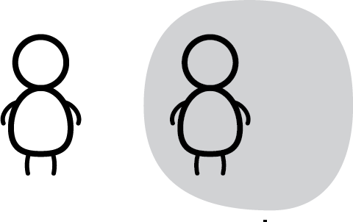 | 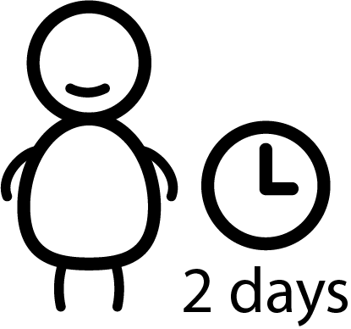 | 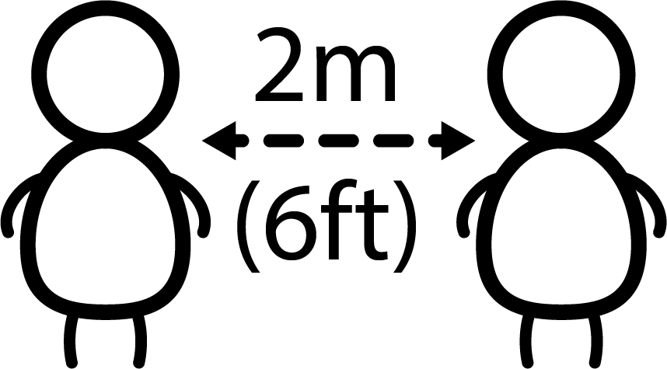
 |  |  | FIRST stay home  and self isolate  for 14 days. | THEN you can stop isolating ONLY when you are symptom free for 2 days. | AFTER isolating continue social distancing.

If you feel  worse | 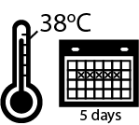  Fever over 38°C (100.4°F) for 5 days | OR | 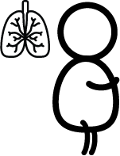  Worse shortness  of breath, even when walking | OR | Feel too sick to  get up or even  watch TV | OR | CALL  Telehealth  1-866-797-0000 or  911 in an emergency

[ Please feel free to swap in these icons and text if your testing guidelines change/differ ]

Travel

Exposure to someone
who has COVID-19

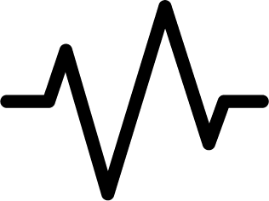

You have signs
of severe illness

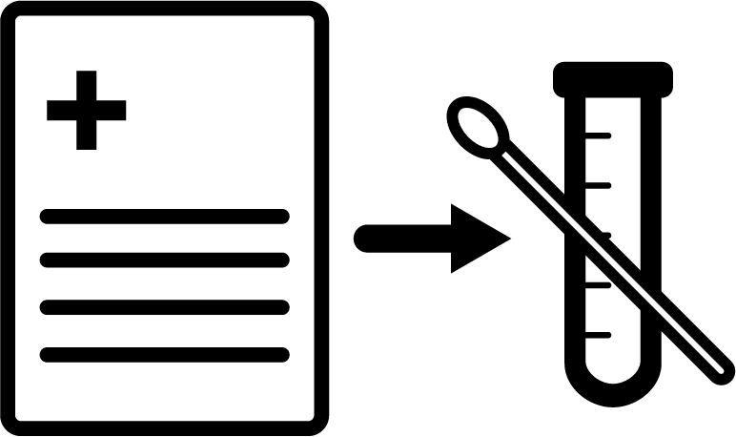
Alternate referral icon

