z
[Hospital/clinic Name Here]  What to do if you might have COVID-19 |  | Don’t go to work.  Send this as  your sick note
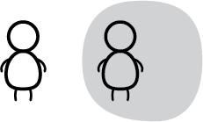 | You need to self-isolate:  - If you had close contact with someone sick or recent travel: for 14 days  - If you have symptoms: for 14 days from when symptoms started  - If you were tested: until you hear from public health on what to do
Most people feel sick (like the flu) and recover well. Only some people get very sick.
You can save lives by staying home.

What you can do to feel better | 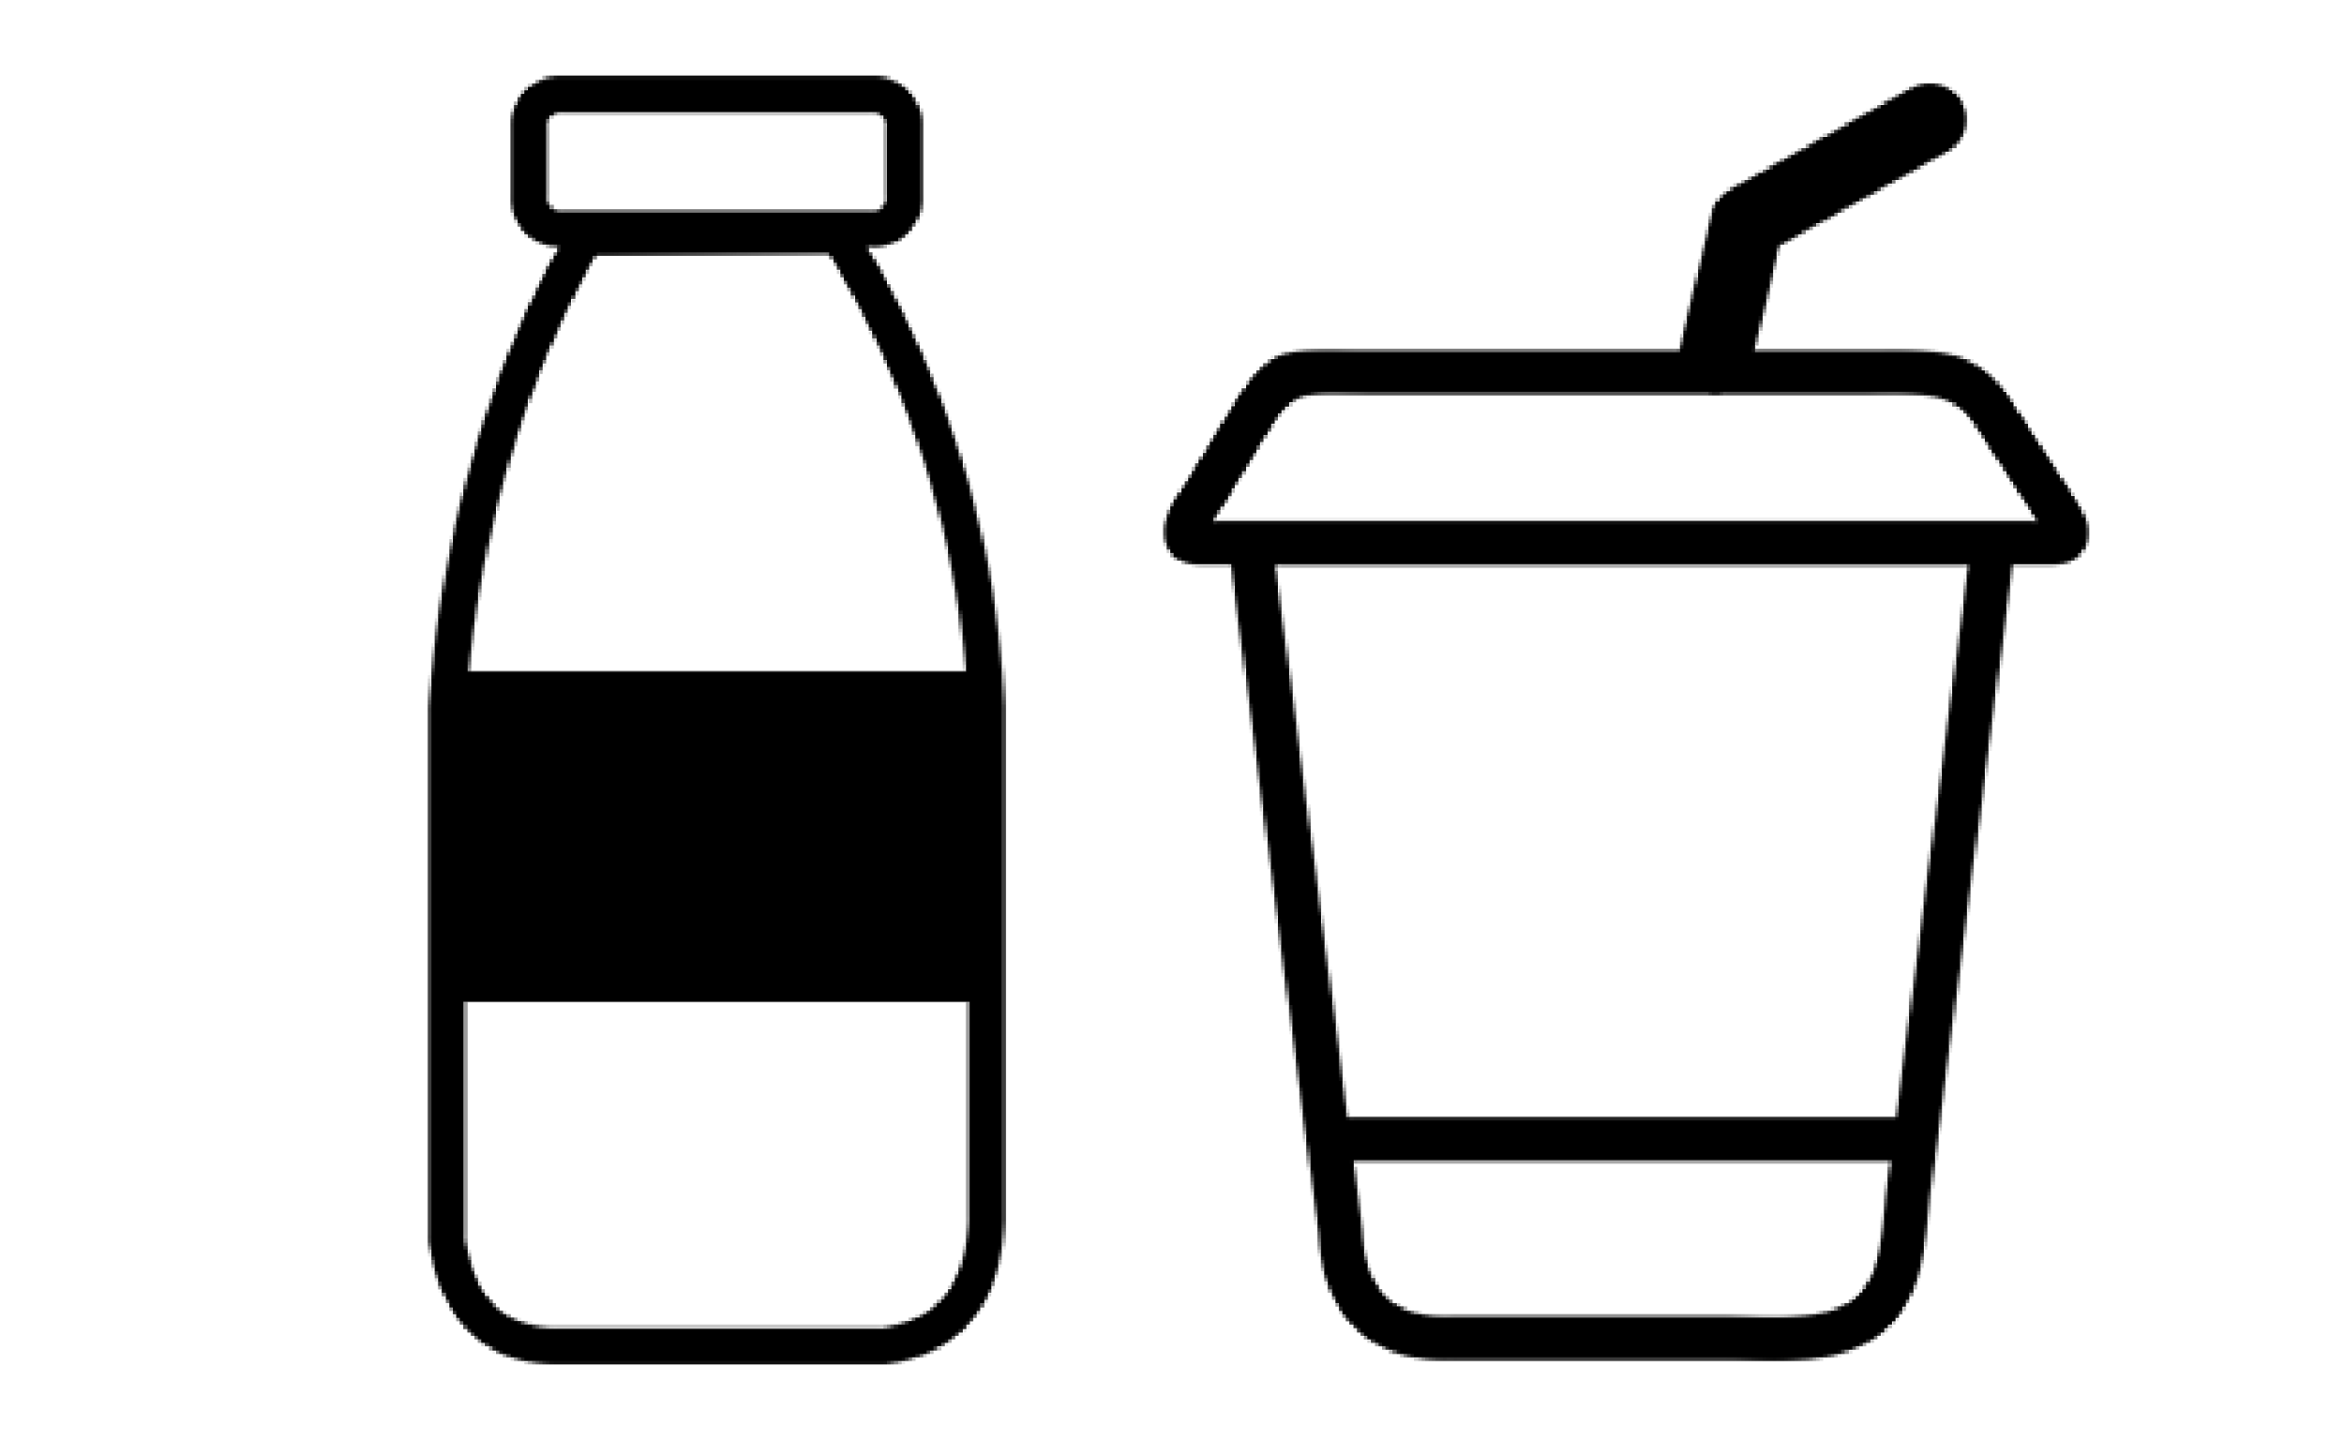 |  |  | 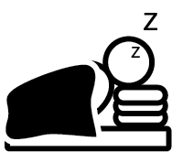
 | Drink fluids | For sore throat  Eat soft foods (soup / smoothies) | Take 6 long, deep breaths a few times a day | If congested  lift your head when sleeping
 | Medications you can safely take | 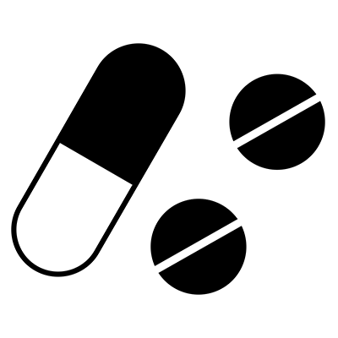 | Acetaminophen (Tylenol):  (Adults) Every 6 hours take  two 325 mg tablets  OR  take two 500 mg tablets
You should feel better in 14 days

What if  you feel  worse? | 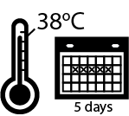 | OR | 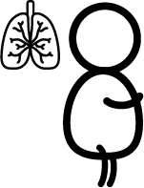 | OR |  | THEN | CALL  Telehealth  1-866-797-0000
 | Fever over  38°C (100.4°F)  for 5 days |  | Shortness of breath, even when walking |  | Feel too sick to  get up or  watch TV
Additional resources: | Public Health Ontario COVID-19  https://bit.ly/covidphontario

